Two Dimensional Arrays
_____________________________________________________________________
Two dimensional array is used for create matrix but it is not matrix internally
It is sequential memory management of array and every block has two digit indexes.

Memory management of two dimensional arrays
________________________________________________________________________________
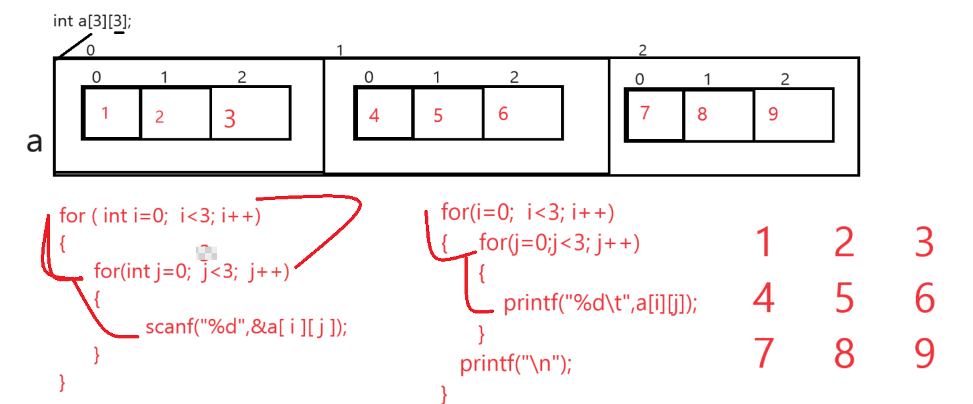
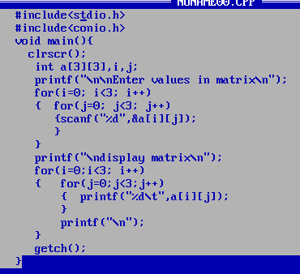
Example: WAP to create 3 x 3 matrix and calculate sum of rows and display it
#include<stdio.h>
#include<conio.h>
void main(){
clrscr();
int a[3][3],b[3][3],c[3][3],i,j,k,sum=0;
printf("\n\nEnter values in matrix\n");
for(i=0; i<3; i++)
{
for(j=0;j<3; j++)
{ scanf("%d",&a[i][j]);
}
}
printf("\nEnter valus in second matrix\n");
for(i=0;i<3; i++)
{
for(j=0;j<3; j++)
{ scanf("%d",&b[i][j]);
}
}
printf("\nDisplay first matrix\n");
for(i=0;i<3;i++)
{
for(j=0;j<3;j++)
{ printf("%d\t",a[i][j]);
}
printf("\n");
}
printf("\nDisplay second matrix\n");
for(i=0;i<3;i++)
{
for(j=0;j<3;j++)
{ printf("%d\t",b[i][j]);
}
printf("\n");
}
//perform matrix multiplication logics

for(i=0;i<3;i++)
{
for(j=0;j<3;j++)
{
sum=0;
for(k=0;k<3;k++)
{ sum = sum+a[i][k]*b[k][j];
}
c[i][j]=sum;
}
}
printf("\nDisplay resultant matrix\n");
for(i=0;i<3;i++)
{
for(j=0;j<3;j++)
{
printf("%d\t",c[i][j]);
}
printf("\n");
}
getch();
}

Example: WAP create 3 x 3 and perform sum of right and left diagonal element from matrix.
#include<stdio.h>
#include<conio.h>
void main(){
clrscr();
int a[3][3],i,j,lsum=0,rsum=0;
printf("\n\nEnter values in matrix\n");
for(i=0; i<3; i++)
{
for(j=0;j<3; j++)
{ scanf("%d",&a[i][j]);
}
}
printf("\nDisplay first matrix\n");
for(i=0;i<3;i++)
{
for(j=0;j<3;j++)
{ printf("%d\t",a[i][j]);
if(i==j)
{ lsum=lsum+a[i][j];
}
if(j==2-i)
{ rsum=rsum+a[i][j];
}
}
printf("\n");
}
printf("\nsum of left diagonal is %d\n",lsum);
printf("\nSum of right diagonal is %d\n",rsum);
getch();
}

